4.1.

Requirement type | Description | Acceptance criterion
Performance | Responsiveness in terms of speed and resources
Security | Information and system protection capabilities
Reliability | Stable operation
Usability | User usability level
Scalability | Growth and upgrade potential
Maintainability | Easy to maintain and upgrade

4.2.

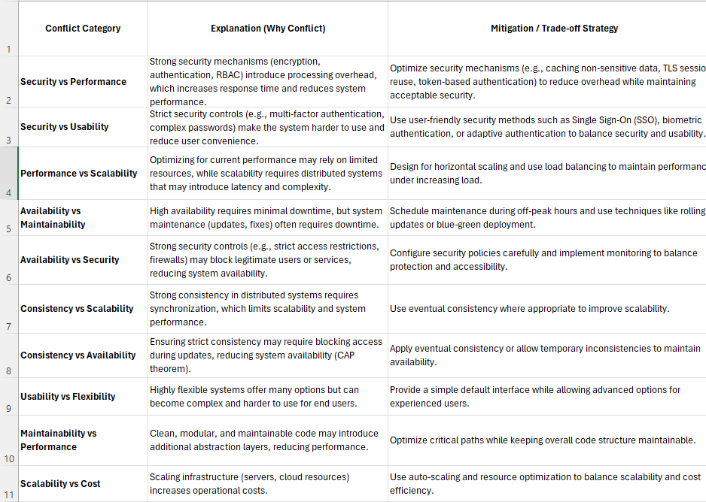

Conflict Category | Explanation (Why Conflict) | Mitigation / Trade-off Strategy
Security vs Performance | Adding robust security measures (like encryption) demands extra processing power, leading to slower response times. | Streamline security processes (e.g., caching, token authentication) to minimize lag without sacrificing safety.
Security vs Usability | Rigid security rules, such as complex passwords or MFA, often create friction and frustrate users. | Implement seamless security solutions like biometrics or Single Sign-On (SSO) for a smoother user experience.
Performance vs Scalability | Tuning a system for immediate speed can limit its growth, while building distributed architectures adds complexity and slight delays. | Utilize load balancers and horizontal scaling strategies so the system remains fast as demand grows.
Availability vs Maintainability | Keeping a system online 24/7 conflicts with the need to take it offline for essential updates and bug fixes. | Perform updates during low-traffic periods or use zero-downtime strategies like blue-green deployments.
Availability vs Security | Overly aggressive security measures (like strict firewalls) can mistakenly lock out valid users, hurting uptime. | Fine-tune security rules and monitor traffic closely to ensure protection doesn't block legitimate access.
Consistency vs Scalability | Keeping data perfectly synced across a distributed network hinders the system's ability to scale out efficiently. | Adopt an "eventual consistency" approach for non-critical data to allow for better scaling.
Consistency vs Availability | Guaranteeing perfect data sync might require locking the system during updates, causing temporary downtime (CAP theorem). | Prioritize keeping the system online by tolerating slight, temporary delays in data syncing across servers.
Usability vs Flexibility | Systems packed with highly customizable features can overwhelm everyday users with a complex interface. | Offer a clean default view for everyday users, while hiding advanced settings for power users.
Maintainability vs Performance | Writing highly organized, modular code often involves adding abstraction layers that can slightly slow down execution. | Keep the codebase clean overall, but heavily optimize the specific code paths that handle the heaviest workloads.
Scalability vs Cost | Expanding server capacity and cloud resources to handle more traffic directly drives up financial expenses. | Implement auto-scaling to dynamically adjust resources based on real-time demand, paying only for what you use.

